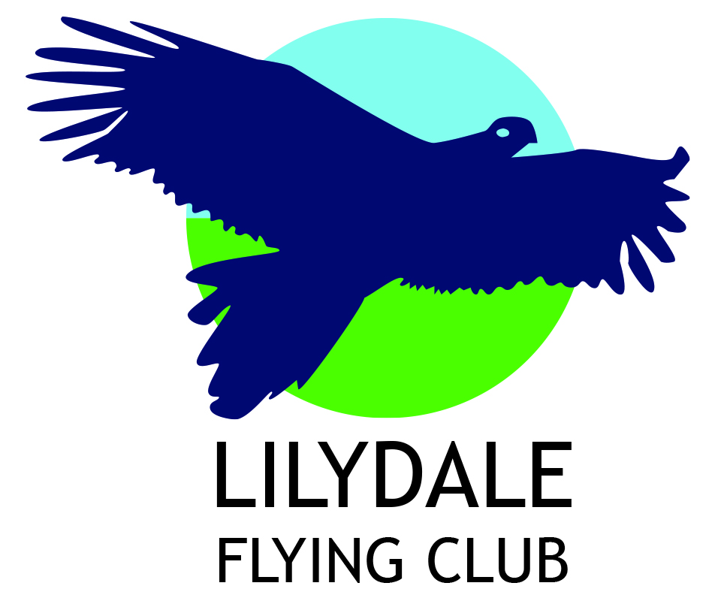

CUP WEEKEND FLYAWAY – BATHURST
“Wings / Wheels / Mountains /Caves”
Saturday Nov. 4 – Tuesday Nov.7

Please join us in our annual cup weekend flyaway with a lot of activities to fill the Sunday and Monday.
Depart late Saturday morning, perhaps lunch stop on the way for refuel/ change of pilot.
Bathurst has fuel and free parking ,but small landing fee. It is Security controlled!
Collect people movers - Cost Approx. $ 60pp( will depend on numbers)
12 seater plus large sedan
Check-in early afternoon to Quality Hotel Bathurst (approx. $80 pp per night breakfast included) where I have booked a mix of double rooms and twin share rooms to cater for singles (either share or if whole room, at extra cost) It has a no cost cancellation date of 3/11/17
Dinner Saturday night :TBA
Sunday – Activities in Bathurst region may include:
Drive around Mt Panorama, Motor racing museum, Wineries, Chifley museum, Regional Art Gallery, Fossil & mineral Museum, History Hill & Hill End Gold area. With more than one vehicle we can pick and choose.
Dinner Sunday night : TBA
Monday: Full day excursion in the vehicles to the Blue Mountain area approx. 90 min away.
En route visit Jenolan caves , possibly Zig Zag Steam railway near Lithgow (if back operational by then), Katoomba with the aerial cable car, skyway, 3 sisters and worlds steepest scenic railway down the hill, walking tracks and lookouts
Dinner Monday night TBA
Tuesday morning Departure after breakfast.

NUMBERS ARE LIMITED

PLEASE SECURE YOUR PLACES by :
1. Deposit of $ 100 per person to:
Commbank : D & V Marty
BSB: 06 3494
Acct : 1001 4351 On the deposit put Surname and Bathurst
2. Email me at www.dmarty@netspace.net.au to let me know you are coming and with whom.
DEADLINE FOR CONFIRMATION IS :
SEPTEMBER 14th

Organisers : Dave Marty ( www.dmarty@netspace.net.au )
Russ Grosvenor ( www.russgrosvenor@bigpond.com )

